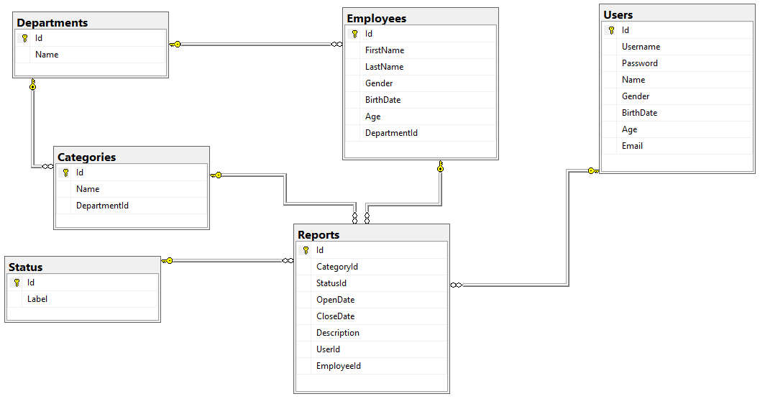

Database Basics MS SQL Exam – 22 Oct 2017
Exam problems for the “Database Basics” course @ SoftUni.
Submit your solutions in the SoftUni Judge system at https://judge.softuni.bg/Contests/819

Report Service
--Mrs. F.Y, the city’s mayor, came up with the idea to create an online platform where all the citizens can report about different problems and a special organization will work to resolve all the incoming reports. This organization has a few departments each of which is responsible for a set of problem’s categories in which users can submit a report. In each department there are employees who get assigned to a report. Of course, this huge platform needs a reliable database to store and process the information and Mrs. Y has asked for the best specialist in this area. That’s why you got chosen! Congratulations and good luck!

Section 1. DDL (30 pts)
You have been given the E/R Diagram of the Report Service:
Crеate a database called ReportService. You need to create 6 tables:
- Users – contains information about the people who submit reports
- Reports - contains information about the submitted problems
- Employees – contains information about the people employees who work on reports
- Departments – contains information about the departments
- Categories – contains information about categories inside the departments.
- Status - contains information about the possible statuses of a report

Users
Column Name | Data Type | Constraints
Id | Integer from 0 to 2,147,483,647 | Unique table identificator, Identity
Username | String up to 30 symbols, Unicode | NULL is not allowed, Unique values only
Password | String up to 50 symbols, Unicode | NULL is not allowed
Name | String up to 50 symbols, Unicode
Gender | Character with exactly 1 symbol | Could be: 'M' or 'F'
BirthDate | DateTime
Age | Integer from 0 to 2,147,483,647
Email | String up to 50 symbols, Unicode | NULL is not allowed

Departments
Column Name | Data Type | Constraints
Id | Integer from 0 to 2,147,483,647 | Unique table identificator, Identity
Name | String up to 50 symbols, Unicode | NULL is not allowed

Employees
Column Name | Data Type | Constraints
Id | Integer from 0 to 2,147,483,647 | Unique table identificator, Identity
FirstName | String up to 25 symbols, Unicode
LastName | String up to 25 symbols, Unicode
Gender | Character with exactly 1 symbol | Could be: 'M' or 'F'
BirthDate | DateTime
Age | Integer from 0 to 2,147,483,647
DepartmentId | Integer from 0 to 2,147,483,647 | NULL is not allowed, Relationship with table Departments

Categories
Column Name | Data Type | Constraints
Id | Integer from 0 to 2,147,483,647 | Unique table identificator, Identity
Name | String up to 50 symbols | NULL is not allowed
DepartmentId | Integer from 0 to 2,147,483,647 | Relationship with table Departments

Status
Column Name | Data Type | Constraints
Id | Integer from 0 to 2,147,483,647 | Unique table identificator, Identity
Label | String up to 30 symbols | NULL is not allowed

Reports
Column Name | Data Type | Constraints
Id | Integer from 0 to 2,147,483,647 | Unique table identificator, Identity
CategoryId | Integer from 0 to 2,147,483,647 | NULL is not allowed, Relationship with table Categories
StatusId | Integer from 0 to 2,147,483,647 | NULL is not allowed, Relationship with table Status
OpenDate | DateTime | NULL is not allowed
CloseDate | DateTime
Description | String up to 200 symbols
UserId | Integer from 0 to 2,147,483,647 | NULL is not allowed, Relationship with table Users
EmployeeId | Integer from 0 to 2,147,483,647 | Relationship with table Employees

Database design
Submit all of yours create statements to Judge (only creation of tables).

Section 2. DML (10 pts)
Before you start you have to import “DataSet-ReportService.sql”. If you have created the structure correctly the data should be successfully inserted.
In this section, you have to do some data manipulations:

Insert
Let’s insert some sample data into the database. Write a query to add the following records into the corresponding tables. All Id’s should be auto-generated. Replace names that relate to other tables with the appropriate ID (look them up manually, there is no need to perform table joins).
Emlpoyees
FirstName | LastName | Gender | Birthdate | Department Id
Marlo | O’Malley | M | 9/21/1958 | Infrastructure
Niki | Stanaghan | F | 11/26/1969 | Emergency
Ayrton | Senna | M | 03/21/1960 | Event Management
Ronnie | Peterson | M | 02/14/1944 | Event Management
Giovanna | Amati | F | 07/20/1959 | Roads Maintenance

Reports
CategoryId | StatusId | OpenDate | CloseDate | Description | UserId | EmployeeId
Snow Removal | waiting | 04/13/2017 |  | Stuck Road on Str.133 | 6 | 2
Sports Events | completed | 09/05/2015 | 12/06/2015 | Charity trail running | 3 | 5
Dangerous Building | in progress | 09/07/2015 |  | Falling bricks on Str.58 | 5 | 2
Streetlight | completed | 07/03/17 | 07/06/2017 | Cut off streetlight on Str.11 | 1 | 1

Update
Switch all report’s status to “in progress” where it is currently “waiting” for the “Streetlight” category (look up the category ID and status ID’s manually, there is no need to use table joins).

Delete
Delete all reports who have a status “blocked”.

Section 3. Querying (40 pts)
You need to start with a fresh dataset, so recreate your DB and import the sample data again (DataSet_ReportService.sql).
If not specified the ordering will be ascending.

Users by Age
Select all Usernames with their age ordered by age (ascending) then by username (descending).
Required columns:
- Username
- Age

Example:
Username | Age
5omarkwelleyc | 19
bkaasg | 21
dfinicj5 | 24
… | …

Unassigned Reports
Find all reports that don’t have an assigned employee. Order the results by open date in ascending order, then by description (ascending).
Required columns:
- Description
- OpenDate

Example:
Description | OpenDate
Art exhibition on July 24 | 2014-12-17 00:00:00.000
Stuck Road on Str.133 | 2015-06-20 00:00:00.000
Burned facade on Str.560 | 2015-08-26 00:00:00.000
… | …

Employees & Reports
Select only employees who have an assigned report and show all reports of each found employee. Show the open date column in the format “yyyy-MM-dd”. Order them by employee id (ascending) then by open date (ascending) and then by report Id (again ascending).
Required columns:
- FirstName
- LastName
- Description
- OpenDate

Example:
FirstName | LastName | Description | OpenDate
Marlo | O'Malley | Fallen streetlight columns on Str.14 | 2017-09-12
Gregory | Stithe | Stuck Road on Str.14 | 2017-04-13
Humphrey | Tamblyn | Burned facade on Str.793 | 2016-07-20
… | … | … | …

Most reported Category
Select ALL categories and order them by the number of reports per category in descending order and then alphabetically by name.
Required columns:
- CategoryName
- ReportsNumber

Example:
CategoryName | ReportsNumber
Recycling | 8
Snow Removal | 5
Streetlight | 4
… | …

Employees in Category
Select ALL categories and the number of employees in each category and order them alphabetically by category name.
Required columns:
- CategoryName
- Employees Number

Example:
CategoryName | Employees Number
Animal in Danger | 3
Art Events | 5
Dangerous Building | 1
… | …

Users per Employee
Select all employees and show how many unique users each of them have served to.
Required columns:
- Employee’s name - Full name consisting of FirstName and LastName and a space between them
- User’s number
Order by Users Number descending and then by Name ascending.

Example:
Name | Users Number
Bron Ledur | 3
Adelind Benns | 2
Dick Wentworth | 2
… | …

Emergency Patrol
Select all reports which satisfy all the following criteria:
- are not closed yet (they don’t have a CloseDate)
- the description is longer than 20 symbols and the word “str” is mentioned anywhere
- are assigned to one of the following departments: “Infrastructure”, “Emergency”, “Roads Maintenance”
Order the results by OpenDate (ascending), then by Reporter’s Email (ascending) and then by Report Id (ascending).
Required columns:
- OpenDate
- Description
- Reporter Email

Example:
OpenDate | Description | Reporter Email
2015-06-20 00:00:00.000 | Stuck Road on Str.133 | bkaasg@g.co
2015-08-26 00:00:00.000 | Burned facade on Str.560 | dpennid@arizona.edu
2015-11-17 00:00:00.000 | Gigantic crater ?n Str.19 | ealpine0@squarespace.com
… | … | …

Birthday Report
Select all categories in which users have submitted a report on their birthday. Order them by name alphabetically.
Required columns:
- Category Name

Example:
Category Name
Dangerous Trees
Homeless Elders
Snow Removal

Numbers Coincidence
Select all unique usernames which:
- starts with a digit and have reported in a category with id equal to the digit
OR
- ends with a digit and have reported in a category with id equal to the digit
Required columns:
- Username
Order them alphabetically.

Example:
Username
1qiskowf
5omarkwelleyc
fdenrico3
…

Open/Closed Statistics
Select all employees who have at least one assigned closed or open report through year 2016 and their total sum. Open reports don’t have a CloseDate. Reports that have been opened before 2016 but were closed in 2016 are counted as closed only! Order by Name (ascending), and then by employee Id
Required columns:
- Name - name - Full name consisting of FirstName and LastName and a space between them
- Closed /Open reports number

Example:
Name | Closed Open Reports
Dick Wentworth | 1/1
Eldon Gaze | 0/1
Hewet Juschke | 0/1
… | …

Average Closing Time
Select all departments that have been reported in and the average time for closing a report for each department rounded to the closest integer part. If there is no information (e.g. none closed reports) about any department fill in the Average Duration column “no info”.
Required columns:
- Department Name
- Average Duration - in days
Order them by department name.

Example:
Department Name | Average Duration
Aged Care | no info
Animals Care | 17
Emergency | no info
… | ….

Favorite Categories
Select all departments with their categories where users have submitted a report. Show the distribution of reports among the categories of each department in percentages without decimal part.
Required columns:
- Department Name
- Category Name
- Percentage
Order them by department name, then by category name and then by percentage (all in ascending order).

Example:
Department Name | Category Name | Percentage
Aged Care | Homeless Elders | 100
Animals Care | Animal in Danger | 75
Animals Care | Street animal | 25
… | … | …

Section 4. Programmability (14 pts)

Employee’s Load
Create a user defined function with the name udf_GetReportsCount(@employeeId, @statusId) that receives an employee’s Id and a status Id returns the sum of the reports he is assigned to with the given status.
Parameters:
- Employee’s Id
- Status Id

Example usage:
Query
SELECT Id, FirstName, Lastname, dbo.udf_GetReportsCount(Id, 2) AS ReportsCount
FROM Employees
ORDER BY Id
Id | FirstName | LastName
1 | Marlo | O'Malley
2 | Nolan | Meneyer
3 | Tarah | McWaters
… | … | …

Assign Employee
Create a user defined stored procedure with the name usp_AssignEmployeeToReport(@employeeId, @reportId) that receives an employee’s Id and a report’s Id and assigns the employee to the report only if the department of the employee and the department of the report’s category are the same. If the assigning is not successful rollback any changes and throw an exception with message: “Employee doesn't belong to the appropriate department!”.
Parameters:
- Employee’s Id
- Report’s Id

Example usage:
Query
EXEC usp_AssignEmployeeToReport 17, 2;
SELECT EmployeeId FROM Reports WHERE id = 2
Response
17

Close Reports
Create a trigger which changes the StatusId to “completed” of each report after a CloseDate is entered for the report.

Example usage:
Query
UPDATE Reports
SET CloseDate = GETDATE()
WHERE EmployeeId = 5;
Response
(1 row affected)

(1 row affected)

Section 5. Bonus (10 pts)

Categories Revision
Select all categories which have reports with status “waiting” or “in progress” and show their total number in the column “Reports Number”. In the third column fill the main status type of reports for the category (e.g. 2 reports with status “waiting” and 3 reports with status “in progress” result in value “in progress”). If they are equal just fill in “equal”. Order by category Name, then by Reports Number and then by Main Status.
Required columns:
- Category Name
- Reports Number
- Main Status

Example:
Category Name | Reports Number | Main Status
Animal in Danger | 1 | in progress
Art Events | 2 | equal
Dangerous Building | 1 | waiting
… | … | …

